Predicting the final seeds of National Basketball Association teams, an ELO based approach

Thomas Abraham  
210639757Hazar Emre Tez  
MSc Computer Science, QMUL

*Abstract*—The introduction of statistical analysis into the National Basketball Association has radically changed the way basketball shot selection and plays are thought about. The ELO algorithm is a popular ranking algorithm used to rank players in a competitive setting. The ELO algorithm is often associated with chess as it is used extensively by FIDE (the governing body of international chess) to determine world rankings of chess players. For the model being considered here, the ELO rating will depend on the players +/- for each game. The model will include both regular season and playoff games. Teams will gain points after winning matches and lose points post defeat. More points are awarded for blowout wins and upsets. Finally, teams will be seeded from one to fifteen in each conference based on their ELO scores. The generated seeds will be validated by creating the model for a previous season and cross-checking its accuracy with real world results.

Keywords—plays, ELO algorithm, playoffs, home-court advantage, blowout, seeded.

# Introduction

The National Basketball Association (NBA) is a men’s professional basketball league in North America, composed of thirty teams divided into western and eastern conferences. Each NBA team has a maximum of fifteen players, out of which thirteen are allowed to be active in each game. Players on a basketball court position themselves in five locations as shown in Figure 1.1. Each of these positions require distinct abilities and physical attributes. These positions are divided into three main categories.[1]

Centre. Centres are usually the tallest players on the team, and they position themselves near the basket. On the offensive side, the centres goal is to make high percentage shots close to the basket. On the defensive end, the centre is responsible for shot blocking and cutting off internal passing lanes. They are also expected to attempt to retrieve defensive and offensive rebounds.

Forward. Forwards are usually the next tallest players on the court and are responsible for passing to cutting players, taking shots, retrieving rebounds in certain instances, and driving to the basket.

Guard. These are likely your shortest players and are responsible for bringing the ball up the court and setting up offensive plays, driving to the basket and long-range shooting.

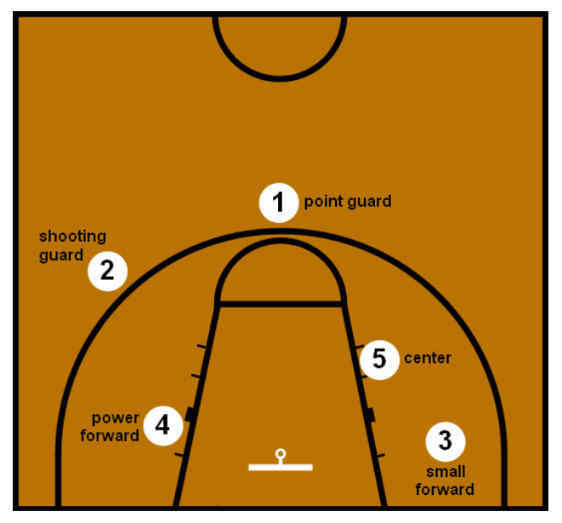

Figure 1.1. Traditional positions in basketball

At the highest level of professional basketball, every play is executed by a team is carefully devised by a team of coaches. Basic plays such as a switch or a give-and-go are widely used and can be situational. However, particular plays such as those centred around off ball movement in order to ensure that a particular player loses their defender are drawn up after taking into consideration the player as well as the defenders ability. The ultimate goal of the offense is to shoot the ball, the strategy lies in devising plays to create good shot opportunities. Defensive plays on the other hand are often drawn up to restrict the movement and ability of one particular player or a set of players. These types of plays are often drawn up after watching a particular player over multiple games and analysing their offensive and defensive capabilities.

General managers such as Darryl Morey set out to prove that data driven decisions would result in a competitive edge. Previously implemented conventional methods used to simulate gameplay and deduce plays have ignored that in a sport such as basketball the dynamics of movement and cohesiveness are unique from line-up to line-up and do not depend solely on individual offensive and defensive ability.

The ELO rating system is popular and widely used, this is mainly because it is elegant yet simple in its execution. A rating system analyses the outcomes of matches and assigns a value to the strength of a team relative to others. This information then allows teams and coaches to make beneficial long term decisions regarding team formation and drafts [4].

# Related Work

Accurate predictions of a team’s seed greatly influences a team’s chances of winning prior to the playoffs. The ability to discern a potential round one matchup at the least will give coaching staff the opportunity to condition players and design game plans specifically suited to their opponents.

Building on previous work [4], this project sets out to create a model that can accurately predict each of the fifteen seeds in both conferences for a season. An ELO based approach is employed to obtain individual player ratings. The individual player ratings are then combined to obtain a team rating. Team ratings are then compared pairwise to obtain the probability of a win by each of the teams during the season. The probable wins are then cumulated, and a seed is calculated for each team. The rating system is validated by running them over real-life data from previous NBA seasons.

# Methodology

The original purpose of the ELO algorithm was to devElop a viable rating system for chess players. As the popularity of the algorithm increased, analysts and statisticians began modifying the algorithm so it could be applied to various other sports. In the simulations being considered here, players alone are not given individual attention when it comes to win prediction. Instead, the team is considered as a single entity.

The true value of a player is not specifically quantifiable and therefore, cannot be measured and analysed. Hence, we depend on the observable metrics of the sport such as points scored, rebounds, assists and so on. The primary statistic being considered in the algorithm is the plus-minus score. The algorithm as a whole is designed to track the performance of individual basketball players and combine their ratings in order to obtain a team score which can then be used in the simulations.

## Plus-Minus Score (+/-)

## ELO Approach

### Player Strength

### Estimate

### K Factor

### F(x)

### Match Outcome

### Seed Outcome

## Algorithms

### Update Team Rating

### Update Player Ratings

### Predict Match Winner

## Datasets

### Physical Data:

The required datasets are obtained by scraping data from the NBA website. The data is obtained from the 2017-2018, 2018-2019 and 2020-2021 regular seasons. Both the player box score and the team box score are recorded.

### Data Scraping

Data or web scraping refers to the process of importing information from a web page, typically written in HTML or XHTML, into a locally saved spreadsheet. A Python program was written to extract the required statistics from online tables and is stored locally as a CSV file.



Fig 3.1 Website containing NBA statistics, reprint from [8]



### Fig 3.2 Scraped data stored in a CSV file

### Synthetic Data

### Initialization

### Metric Calculation

## Units

* Use either SI (MKS) or CGS as primary units. (SI units are encouraged.) English units may be used as secondary units (in parentheses). An exception would be the use of English units as identifiers in trade, such

# Results

# Conclusion

The ELO algorithm is a widely used rating system due to its simplicity and the fact that it offers relatively high prediction accuracy. The main reason it was selected is because the algorithm considers the whole team as a fundamental unit. In the models being discussed above, a modified version of the ELO algorithm is used where a team’s performance is modelled using the +/- metric of individual players. Individual player ratings are combined to obtain a team rating which is then used to predict the outcome of matches. The chosen algorithm is compared with the base ELO algorithm by analysiing

# Future Work

##### References

1. Franks, Alexander M., D’Amour, Alexander, Cervone, Daniel and Bornn, Luke. “Meta-analytics: tools for understanding the statistical properties of sports metrics” Journal of Quantitative Analysis in Sports, vol. 12, no. 4, 2016, pp. 151-165. DOI: <https://doi.org/10.1515/jqas-2016-0098>.
2. Elo, Arpad E. “The Rating of Chessplayers, Past and Present. New York: Arco Pub, ” 1978. Print.
3. Hao Ji, Erich O’Saben, Adam Boudion, and Yaohang Li. “March Madness Prediction : A Matrix Completion Approach” 2015.
4. Marveldoss, Richard Einstein Doss. “An Elo-Based Approach to Model Team Players and Predict the Outcome of Games, “ August 2018 unpublished. URI: <https://hdl.handle.net/1969.1/173956>.
5. Song Yan, Siyuan Meng, Qiwei Liu, Jing Li. “Design and Implementation of NBA Playoff Prediction Method Based on ELO Algorithm and Graph Database, ” November 2019. ISSN 23275219. DOI: <https://doi.org/10.4236/jcc.2019.711004>.
6. Raquel YS Aoki, Renato M Assuncao, Pedro OS Vaz de MElo. “Luck is Hard to Beat: The Difficulty of Sports Prediction” June 2017. DOI: <https://doi.org/10.48550/arXiv.1706.02447>.
7. Keshri, Suraj Kumar. “Essays in Basketball Analytics, ” September 2019, unpublished. DOI: <https://doi.org/10.7916/d8-1ghx-zy51>.
8. National Basketball Association (2022).Player Box Score Search [online].

Availabile at: [https://www.nba.com/stats/search/player-game/?CF=PTS*gt*40](https://www.nba.com/stats/search/player-game/?CF=PTS*gt*40) [Accessed July 2022].

1. A raw version of the data mentioned is available at https://www.myactivesg.com/Sports/Basketball/How-To- Play/Basketball-Rules/Basketball-Positions-and-Roles